

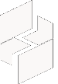

MICROSOFT ARCHITECTURE BEST PRACTICE FOR SECURITY
USECASE: MIGRATING CLOUD WORKLOADS ACROSS SECURITY TENANTS
Document Title | MIGRATING CLOUD WORKLOADS ACROSS SECURITY TENANTS
Presales/Technical Head | Tushar Mehrotra/Rohit Pandey
CCoE Lead | Ravishankar N
Creation Date | January 2026
Version | Description | Modified by | Date | Approved by | Date
1 | Initial Architecture design | AJEET KUMAR | 15/01/2026 | Ravi Shankar | 15/03/2026
2 | Reusability & scalability | AJEET KUMAR | 20/01/2026 | Ravi Shankar | 20/03/2026

Contents
1
1. Executive Summary 2
2. Scope and Applicability 3
3. Business Scenario Overview 3
4. Reference Architecture Overview 4
4.1 Architecture Description 4
5. Logical Architecture Components 4
5.1 Identity and Tenant Boundary Management 4
5.2 Infrastructure as Code and Resource Deployment 4
5.3 Data and Workload Migration Layer 5
5.4 Sidecar Subscription Strategy 5
5.5 Subscription and Resource Movement 5
5.6 Security and Governance Controls 5
6. Cloud Center of Excellence (CCoE) Enablement Model 5
7. Reusability and Scalability 5
8. Conclusion 6

1. Executive Summary
This document is based on a secure reference architecture for migrating cloud workloads across security tenants. The architecture supports scenarios where organizations must move Azure resources from one Microsoft Entra ID tenant to another while preserving security boundaries, governance controls, and business continuity.
The approach aligns with Microsoft principles of secure by design, least privilege, and defense in depth, and provides standardized guidance for governed enterprise environments.

2. Scope and Applicability
This reference architecture applies to:
- Cross-tenant Azure workload migration scenarios
- Mergers, acquisitions, and divestitures
- Tenant consolidation or separation initiatives
- Regulated and security-bound enterprise environments
- CSP, enterprise IT, and CCoE-governed Azure platforms
The architecture focuses on maintaining security isolation, compliance, and operational continuity during migration.

3. Business Scenario Overview
During major business transformations, organizations often need to separate or merge cloud environments across different Microsoft Entra ID tenants. These scenarios include acquisitions, carve-outs, divestitures, or organizational restructuring.
A direct lift-and-shift approach across tenants introduces risks such as:
- Loss of security boundaries
- Identity and access misconfiguration
- Data integrity issues
- Prolonged downtime
This reference architecture defines a controlled, step-by-step migration strategy that ensures workloads are moved securely while minimizing business disruption.

4. Reference Architecture Overview
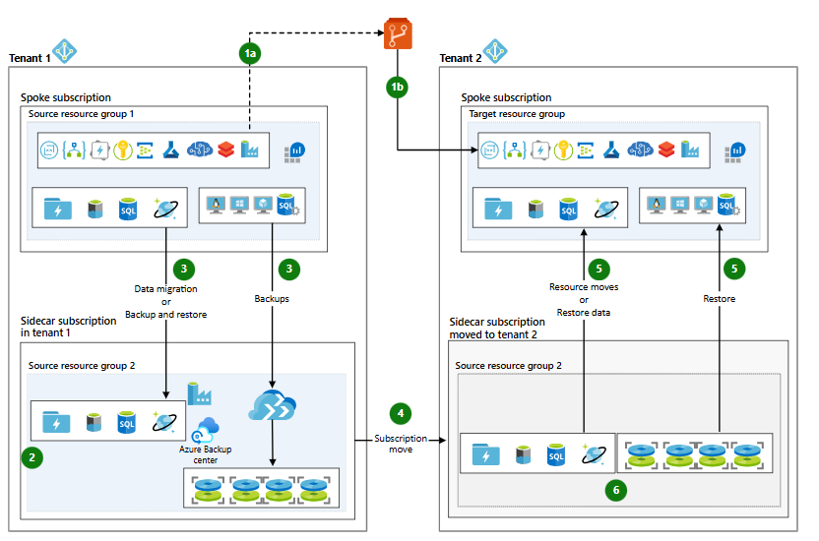

4.1 Architecture Description
The architecture implements a phased cross-tenant migration model built around Infrastructure as Code (IaC), temporary isolation, and controlled data movement. The process includes:
- Re-deploying infrastructure in the target tenant
- Cloning data and state securely
- Migrating subscriptions and restoring workloads
A temporary sidecar subscription is used to host backups and cloned resources before final migration.

5. Logical Architecture Components

5.1 Identity and Tenant Boundary Management
- Microsoft Entra ID for tenant-level identity isolation
- Cross-tenant trust and access modeling
- Strict separation of source and target tenant identities
This layer ensures security boundaries are preserved during migration.

5.2 Infrastructure as Code and Resource Deployment
- Azure Resource Manager (ARM) templates
- Configuration files stored in source control repositories
- Automated deployment to target tenant subscriptions
This enforces consistency, repeatability, and ability.

5.3 Data and Workload Migration Layer
- Azure Data Factory for structured data migration
- AzCopy for large-scale data movement
- Native backup and restore mechanisms for supported services
This layer enables secure and controlled data replication across tenants.

5.4 Sidecar Subscription Strategy
- Temporary subscription created in the source tenant
- Hosts cloned data services and VM backups
- Isolated from production subscriptions
The sidecar subscription acts as a controlled staging environment during migration.

5.5 Subscription and Resource Movement
- Azure subscription moved to the new tenant
- Resources restored or mapped to pre-created target resource groups
- Validation performed before decommissioning temporary resources
This ensures clean tenant separation or consolidation.

5.6 Security and Governance Controls
- Azure RBAC redefined in the target tenant
- Azure Policy and governance controls re-applied
- Logging, monitoring, and compliance validation
Security posture is validated before final cutover.

6. Cloud Center of Excellence (CCoE) Enablement Model
The CCoE leverages this architecture to:
- Define standardized cross-tenant migration patterns
- Enforce security and compliance standards
- Provide reusable IaC templates and runbooks
This enables consistent execution across business transformation programs.

7. Reusability and Scalability
- Reusable across multiple migration initiatives
- Scales from single workloads to full tenant migrations
- Applicable across regions and regulated environments

8. Conclusion
The Migrate Cloud Workloads Across Security Tenants Reference Architecture provides a secure, Microsoft-aligned framework for executing complex cross-tenant migrations. It enables organizations to maintain security boundaries, governance, and operational continuity during critical business transformations.

